**A Project Report on**

# VEHICLE PARKING SYSTEM

### Submitted for partial fulfillment of the requirements for the subject

Web Technology (TE, VIth Semester)

### OF

BACHELOR OF ENGINEERING

### BY

Mr. Chetan Lande (Roll No.TCOB54)

Mr. Sairam Shinde (Roll No.TCOB57)

### Under the Guidance of Prof. Swapnil Deshmukh



##### Dr. D. Y. Patil Unitech Society’s Dr. D. Y. Patil Institute of Technology

**Sant Tukaram Nagar, Pimpri, Pune-18 Affiliated to Savitribai Phule Pune University,**

**DEPARTMENT OF COMPUTER ENGINEERING**



**CERTIFICATE**

### This is to certify that the project work entitled “**VEHICLE PARKING SYSTEM**” is a bonafide work carried out by Mr. Chetan Lande, Sairam Shinde in partial fulfillment of the requirements for the subject. Web Technology (TE, 6th Semester) of degree of Bachelor of Engineering in Third Year Engineering from Dr. D. Y. Patil Institute of Technology, Pimpri during the academic year 2023-2024

Prof. Swapnil Deshmukh Prof. (Dr.) Vinod V. Kimbahune

(Guide) (Head of Department)

Department of Computer Engineering Department of Computer Engineering

Dr. DYPIT, Pune Dr. DYPIT, Pune

Prof. (Dr.) Lalit Kumar Wadhwa

(Principal)

Dr. DYPIT, Pune

# ACKNOWLDGEMENT

### We extend our sincere gratitude to our esteemed Head of Department, Dr Vinod V. Kimbahune, for her valuable guidance, support, and expertise throughout the duration of this project. Her leadership and mentorship have been instrumental in shaping our project and ensuring its successful completion.

We would also like to express our deep appreciation to our dedicated guide, Mr. Swapnil Deshmukh for her constant interest, encouragement, and invaluable guidance. Her expertise and insights have been invaluable in navigating the challenges of the project and steering us in the right direction.

### Furthermore, we would like to thank all our teachers for their continuous support and guidance throughout the project. Their knowledge and expertise have been instrumental in shaping our understanding and refining our work.

Lastly, we would like to express our gratitude to the entire teaching and non-teaching staff, as well as our friends, for their support and assistance during the course of this project. Their contributions, whether direct or indirect, have been immensely valuable in the successful completion of our project work.

# TABLE OF CONTENTS

## Titles Page No.

⁕ Abstract

1. Introduction 01
   1. Problem statement and Description
   2. Advantages
   3. Applications
2. Web Technologies Used 03
   1. Use Case diagram
3. Software Requirements 11
4. Results 18
5. Github Link 19

# ABSTRACT

The Vehicle Parking System is an innovative web technology project developed using a combination of PHP, HTML, CSS, and more. It serves as a comprehensive solution for managing the flow of vehicles within a parking area. This system is designed to efficiently handle the records of incoming and outgoing vehicles, making it an invaluable tool for various public spaces, including malls, multiplexes, hospitals, and offices.

The primary objective of this project is to create a streamlined and user-friendly Vehicle Parking System that empowers operators to control vehicle access based on their unique registration numbers. It keeps a meticulous record of each vehicle's entry and exit, providing real-time information about the cars present in the parking lot.

In contemporary times, the challenges of managing vehicle parking have become increasingly critical. Crowded public places often struggle to accommodate the influx of vehicles, leading to congestion, confusion, and even disputes. Traditional parking management methods involve significant manual labor, increasing operational costs for parking area owners. Furthermore, towing vehicles can be a hassle for both the drivers and the parking operators.

The Vehicle Parking System seeks to address these issues by offering a safe, secure, and cost- effective alternative. It allows vehicle owners to park their cars with peace of mind, knowing that their vehicles are in a secure environment. The system also offers features to monitor and control vehicle access, making it easier to manage parking space efficiently.

One of the key functionalities of this system is the ability to evaluate and impose fees for every vehicle's entry and exit. This helps in generating revenue for the parking area while ensuring that vehicle owners pay a fair and reasonable fee for using the facility. The fee structure can be customized to suit the specific needs and policies of the parking area, ensuring flexibility in pricing.

In summary, the Vehicle Parking System is a technological marvel that not only simplifies the complex task of parking management but also enhances security and convenience for vehicle owners. It serves as a solution to the growing challenges faced by public spaces in managing vehicle parking, offering a win-win situation for both operators and vehicle owners.

# 1) INTRODUCTION

Vehicle Parking System is a system to manage the records of the incoming and outgoing vehicles in a parking slot. The four most basic operations that can be performed with database systems are Create, Read. Update, and Delete, they are backbone for interacting with any database.

The following operations can be performed on Database:

* Creating the database
* Reading from the database
* Updating the database
* Deleting the database
* Inserting to the database
* Searching the database

## 1.2 PROBLEM STATEMENT & DESCRIPTION

To design a Vehicle Parking System using PHP and MySQL along with HTML, CSS, JavaScript and Bootstrap.

The Vehicle Parking System project in PHP focuses mainly on keeping track of vehicle’s parking. Also, the system displays all the vehicle’s entry and outgoing records. In addition, the system allows adding vehicle categories too. This project only contains an admin panel. In an overview of this web application, an admin has all control over the system. He helps to maintain the flow of the system. An admin can simply add vehicle categories by providing category names. After the management of vehicle categories, the admin can simply insert the vehicle’s entry. For this, he has to enter the vehicle’s number, model name, category, and owner’s information.

After setting up the vehicle’s parking, now the admin can manage outgoing vehicles. Here, the admin, who is an user can simply take an action for checking out the parking. In order to exit a vehicle’s parking, the admin has to enter the total parking charge with remarks manually. Once a vehicle exits the parking, those records can be found under the outgoing vehicle records. Here, the system generates invoice receipts for each and every vehicle. The user can view details of each available vehicle. Also, the user can view and print out the parking receipt of each. Each record consists of parking number, total charge, vehicle registration number, owner details, and more.

On the other hand, an admin can list out the reports between dates. These reports help out to state vehicle’s parking records between the selected dates. The steps are simple, the user only needs to select from and to date. And after that, the system displays it all between those mentioned dates where the user can also view their details. Additionally, the admin can view total earnings to date. And also, the system displays the current date total earning. He/she can search out the vehicle’s record using the vehicle’s registration number from the sidebar. Besides, an admin can have an overview records of the total vehicle’s entry with a number of in and out vehicles and total parking within a 24 hours span time. The system represents overall records using graphical charts like piechart to present a summary of records. And finally additional features in this system includes updating the user’s profile where user can update his name and contact details. Also, an admin can change the password by entering the current password with a new and confirmation password. The last feature is about company information. The system allows the user to update company settings. It includes of company’s name, the company’s email address, website URL, and company’s address. Hence the available features are as follows:

* Dashboard
* Vehicle Entry
* IN Vehicles
* OUT Vehicles
* Vehicle Category
* View Reports
* Total Income

## ADVANTAGES OF PROPOSED SYSTEM

The advantages of Vehicle Parking System are as follows:

* It becomes easier for administrator to retrieve information about in-vehicles and out-vehicles.
* It reduces Operational and Management Costs.
* Easy to manage and maintain
* Authentication during log-in ensures security.
* Graphical Representation of Data helps in analysing.

## APPLICATIONS OF PROPOSED SYSTEM

* In public places such as malls, multiplex complex, hospitals, hotels, offices, market areas.
* Part of this system has implementation in Tollgate Management System.
* In implementation of Automated Parking System.

# 3) WEB TECHNOLOGY USED

#### XAMPP Server:

XAMPP is an abbreviation for cross-platform, Apache, MySQL, PHP and Perl, and it allows you to build WordPress site offline, on a local web server on your computer. This simple and lightweight solution works on Windows, Linux, and Mac – hence the “cross-platform” part.. Xampp server allows you to setup a local server with the same characteristics as your production.

#### MySQL:

MySQL is currently the most popular database management system software used for managing the relational database. It is open-source database software, which is supported by Oracle Company. It is fast, scalable, and easy to use database management system in comparison with Microsoft SQL Server and Oracle Database. It is commonly used in conjunction with PHP scripts for creating powerful and dynamic server-side or web-based enterprise applications.

It is developed, marketed, and supported by MySQL AB, a Swedish company, and written in C programming language and C++ programming language. However, you can pronounce it in your way. Many small and big companies use MySQL. MySQL supports many Operating Systems like Windows, Linux, MacOS, etc. with C, C++, and Java languages.

MySQL is a Relational Database Management System (RDBMS) software that provides many things, which are as follows:

* It allows us to implement database operations on tables, rows, columns, and indexes.
* It defines the database relationship in the form of tables (collection of rows and columns), also known as relations.
* It provides the Referential Integrity between rows or columns of various tables.
* It allows us to updates the table indexes automatically.
* It uses many SQL queries and combines useful information from multiple tables for the end-users.

MySQL follows the working of Client-Server Architecture. This model is designed for the end-users called clients to access the resources from a central computer known as a server using network services. Here, the clients make requests through a graphical user interface (GUI), and the server will give the desired output as soon as the instructions are matched. The process of MySQL environment is the same as the client-server model. The core of the MySQL database is the MySQL Server. This server is available as a separate program and responsible for handling all the database instructions, statements, or commands.

The working of MySQL database with MySQL Server are as follows:

* MySQL creates a database that allows you to build many tables to store and manipulate data and defining the relationship between each table.
* Clients make requests through the GUI screen or command prompt by using specific SQL expressions on MySQL.
* Finally, the server application will respond with the requested expressions and produce the desired result on the client-side.

#### phpMyAdmin:

It is a free software tool written in PHP, intended to handle the administration of MySQL over the Web. phpMyAdmin supports a wide range of operations on MySQL and MariaDB. Frequently used operations (managing databases, tables, columns, relations, indexes, users, permissions, etc) can be performed via the user interface, while you still have the ability to directly execute any SQL statement.

Features provided by the program include:

* Web interface
* MySQL and MariaDB database management
* Import data from CSV, JSON and SQL
* Export data to various formats: CSV, SQL, XML, JSON, PDF (via the TCPDF library), ISO/IEC 26300

- OpenDocument Text and Spreadsheet, Word, Excel, LaTeX, SQL, and others

* Administering multiple servers
* Creating PDF graphics of the database layout
* Creating complex queries using query-by-example (QBE)
* Searching globally in a database or a subset of it
* Transforming stored data into any format using a set of predefined functions, like displaying BLOB-data as image or download-link
* Live charts to monitor MySQL server activity like connections, processes, CPU/memory usage, etc.
* Network traffic to the SQL server
* Working with different operating systems like Windows*, Linux*, OS/2, Free BSD* Unix* ( such as Sun* Solaris* , AIX) and others.
* Make complex SQL queries easier.

#### Visual Studio Code:

Visual Studio Code is a source-code editor made by Microsoft for Windows, Linux and macOS. Features include support for debugging, syntax highlighting, intelligent code completion, snippets, code refactoring, and embedded Git. Users can change the theme, keyboard shortcuts, preferences, and install extensions that add additional functionality.

Visual Studio Code is a source-code editor that can be used with a variety of programming languages, including Java, JavaScript, Go, Node.js, Python and C++.It is based on the Electron framework, which is

used to develop Node.js Web applications that run on the Blink layout engine. Instead of a project system, it allows users to open one or more directories, which can then be saved in workspaces for future reuse. This allows it to operate as a language-agnostic code editor for any language. It supports a number of programming languages and a set of features that differs per language. Unwanted files and folders can be excluded from the project tree via the settings. Many Visual Studio Code features are not exposed through menus or the user interface but can be accessed via the command palette.

Visual Studio Code can be extended via extensions, available through a central repository. This includes additions to the editor and language support. A notable feature is the ability to create extensions that add support for new languages, themes, and debuggers, perform static code analysis, and add code linters using the Language Server Protocol.

##### Google Chrome:

Google Chrome is a cross-platform web browser developed by Google. It was first released in 2008 for Microsoft Windows, built with free software components from Apple WebKit and Mozilla Firefox. It was later ported to Linux, macOS, iOS, and Android, where it is the default browser. The browser is also the main component of Chrome OS, where it serves as the platform for web applications.

**2.3**

**FUNCTIONAL REQUIREMENT**

## HTML:

HTML (Hypertext Markup Language) is the most basic building block of the Web. It defines the meaning and structure of web content. Other technologies besides HTML are generally used to describe a web page's appearance/presentation (CSS) or functionality/behaviour (JavaScript).

"Hypertext" refers to links that connect web pages to one another, either within a single website or between websites. Links are a fundamental aspect of the Web. By uploading content to the Internet and linking it to pages created by other people, you become an active participant in the World Wide Web. HTML uses "markup" to annotate text, images, and other content for display in a Web browser. HTML markup includes special "elements" such as <head>, <title>, <body>, <header>, <footer>, <article>, <section>, <p>, <div>,

<span>, <img>, <nav>, < <ul>, <ol>, <li> and many others. HTML elements are the building blocks of HTML pages. With HTML constructs, images and other objects like interactive forms can be embedded into the rendered page. It provides a way to create structured documents by denoting structural semantics for the text like headings, paragraphs, lists, links, quotes and other items.

* + 1. ***CSS:***

Cascading Style Sheets (CSS) is a stylesheet language used to describe the presentation of a document written in HTML or XML (including XML dialects such as SVG, MathML or XHTML). CSS describes how elements should be rendered on screen, on paper, in speech, or on other media. CSS saves a lot of work. It can control the layout of multiple web pages all at

CSS is designed to enable the separation of presentation and content, including layout, colors, and fonts. This separation can improve content accessibility; provide more flexibility and control in the specification of presentation characteristics; enable multiple web pages to share formatting by specifying the relevant CSS in a separate .css file, which reduces complexity and repetition in the structural content; and enable the .css file to be cached to improve the page load speed between the pages that share the file and its formatting. Separation of formatting and content also makes it feasible to present the same markup page in different styles for different rendering methods, such as on-screen, in print, by voice (via speech-based browser or screen reader), and on Braille-based tactile devices. CSS also has rules for alternate formatting if the content is accessed on a mobile device.

#### JavaScript:

JavaScript (JS) is a lightweight, interpreted, or just-in-time compiled programming language with first-class functions. While it is most well-known as the scripting language for Web pages, many non-browser environments also use it, such as Node.js, Apache CouchDB and Adobe Acrobat. JavaScript is a prototype- based, multi-paradigm, single-threaded, dynamic language, supporting object-oriented, imperative, and declarative (e.g. functional programming) styles.

Over 97% of websites use JavaScript on the client side for web page behavior, often incorporating third-party libraries. All major web browsers have a dedicated JavaScript engine to execute the code on users' devices. It has dynamic typing, prototype-based object-orientation,

and first-class functions. It is multi-paradigm, supporting event-driven, functional, and imperative programming styles. It has application programming interfaces (APIs) for working with text, dates, regular expressions, standard data structures, and the Document Object Model (DOM).

JavaScript engines were originally used only in web browsers, but are now core components of some servers and a variety of applications. The most popular runtime system for this usage is Node.js. Although Java and JavaScript are similar in name, syntax, and respective standard libraries, the two languages are distinct and differ greatly in design.

#### Bootstrap:

Bootstrap is a free and open-source CSS framework directed at responsive, mobile-first front-end web development. It contains CSS- and (optionally) JavaScript-based design templates for typography, forms, buttons, navigation, and other interface components.

Bootstrap is an HTML, CSS & JS Library that focuses on simplifying the development of informative web pages (as opposed to web apps). The primary purpose of adding it to a web project is to apply Bootstrap's choices of color, size, font and layout to that project. As such, the primary factor is whether the developers in charge find those choices to their liking.

Once added to a project, Bootstrap provides basic style definitions for all HTML elements. The result is a uniform appearance for prose, tables and form elements across web browsers. In addition, developers can take advantage of CSS classes defined in Bootstrap to further customize the appearance of their contents. For example, Bootstrap has provisioned for light- and dark-coloured tables, page headings, more prominent pull quotes, and text with a highlight.

Bootstrap also comes with several JavaScript components in the form of jQuery plugins. They provide additional user interface elements such as dialog boxes, tooltips, and carousels. Each Bootstrap component consists of an HTML structure, CSS declarations, and in some cases accompanying JavaScript code. They also extend the functionality of some existing interface elements, including for example an auto-complete function for input fields.

The most prominent components of Bootstrap are its layout components, as they affect an entire web page. The basic layout component is called "Container", as every other element in the page is placed in it. Developers can choose between a fixed-width container and a fluid-width container. While the latter always fills the width of the web page, the former uses one of the five predefined fixed widths, depending on the size of the screen showing the page:

* Smaller than 576 pixels
* 576–768 pixels
* 768–992 pixels
* 992–1200 pixels
* Larger than 1200 pixels

Once a container is in place, other Bootstrap layout components implement a CSS Flexbox layout through defining rows and columns.

#### PHP:

PHP is a popular general-purpose scripting language that is especially suited to web development. PHP code is usually processed on a web server by a PHP interpreter implemented as a module, a daemon or as a Common Gateway Interface (CGI) executable. On a web server, the result of the interpreted and executed PHP code – which may be any type of data, such as generated HTML or binary image data – would form the whole or part of an HTTP response. Various web template systems, web content management systems, and web frameworks exist which can be employed to orchestrate or facilitate the generation of that response.

PHP is very popular language because of its simplicity and open source. There are some important features of PHP given below:

* + - * Performance:

PHP script is executed much faster than those scripts which are written in other languages such as JSP and ASP. PHP uses its own memory, so the server workload and loading time is automatically reduced, which results in faster processing speed and better performance.

* + - * Open Source

PHP source code and software are freely available on the web. You can develop all the versions of PHP according to your requirement without paying any cost.

* + - * Embedded

PHP code can be easily embedded within HTML tags and script.

* + - * Platform Independent

PHP is available for WINDOWS, MAC, LINUX & UNIX operating system. A PHP application developed in one OS can be easily executed in other OS also.

* + - * Database Support

PHP supports all the leading databases such as MySQL, SQLite, ODBC, etc.

* + - * Web servers Support

PHP is compatible with almost all local servers used today like Apache, Netscape, Microsoft IIS.

* + - * Security

PHP is a secure language to develop the website. It consists of multiple layers of security to prevent threads and malicious attacks.

* + - * Control

Different programming languages require long script or code, whereas PHP can do the same work in a few lines of code. It has maximum control over the websites like you can make changes easily whenever you want.

# CHAPTER 2

**6.2 REQUIREMENTS**

## 2.1 HARDWARE REQUIREMENT

The Hardware requirements are very minimal and the program can be run on most of the machine.

|  |  |
| --- | --- |
| Processor Type | Pentium iv or above for optimum performance |
| System RAM | 2.00GB and above |
| Input Device | Standard Input Device Keyboard |
| Output Device | Standard Output Device Monitor(display screen) |

## SOFTWARE REQUIREMENT

The software requirements are as follows:

Operating System Windows 10

|  |  |
| --- | --- |
| XAMPP Server | MySQL, phpMyAdmin |
| IDE | Visual Studio Code |
| Browser | Google Chrome |

#### 2.2.1 Operating System:

An operating system (OS) is system software that manages computer hardware, software resources, and provides common services for computer programs. One such operating system is Windows 10. WINDOWS 10 provides desktop oriented interface. It is a major release of the Windows NT operating system developed by Microsoft. It is the successor to Windows 8.1, released nearly two years earlier, and was released to manufacturing on July 15, 2015.

# 7) RESULTS

## 5.1 WEB INTERFACE SNAPSHOTS



Fig: 5.1.1 Login Page

Login page is where the admin can login into the website with the credentials like username and password. After the login button is pressed, admin can login successfully.

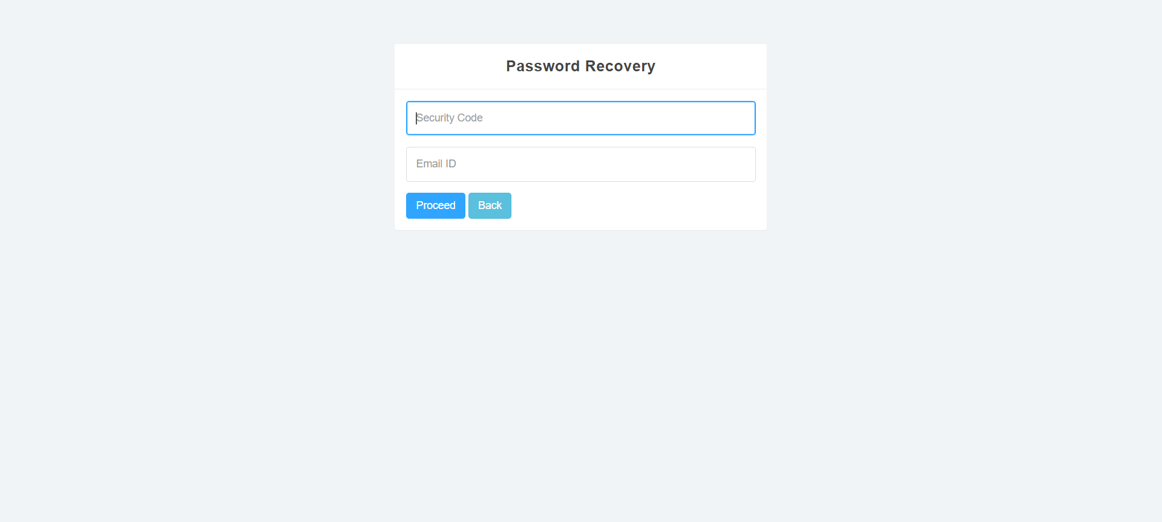

Fig: 5.1.2 Password Recovery

If in case, admin forgets the password then, he can update the password using security code provided by the company and his email ID.

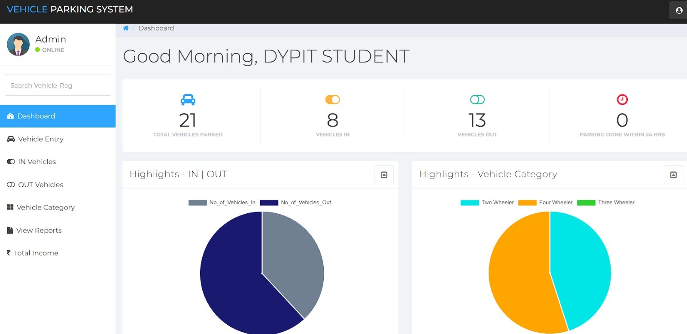

Fig: 5.1.3 Dashboard

This snapshot shows the dashboard features available. The vehicle category pie chart gives information about number of vehicles parked according to the category. The in-out pie chart differentiates between number of in and out vehicles.

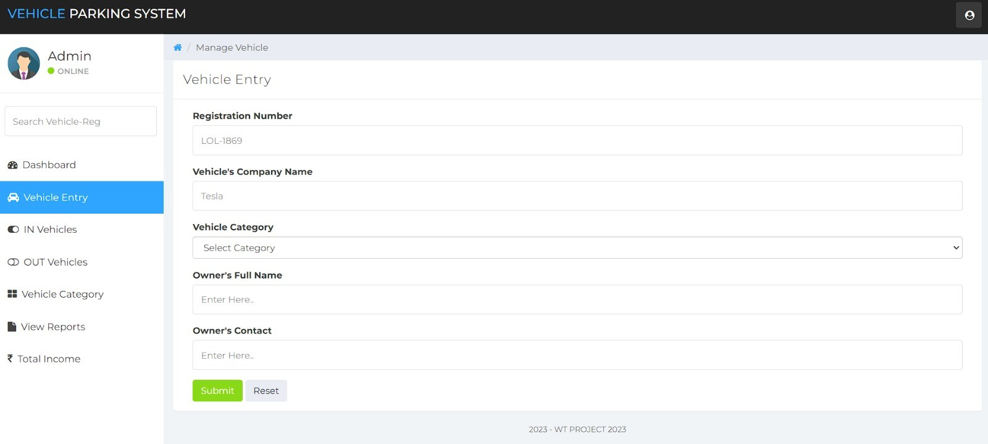

Fig: 5.1.4 Vehicle Entry

With the help of vehicle entry feature, details about the vehicle entered into the parking area and its owner is registered. 12

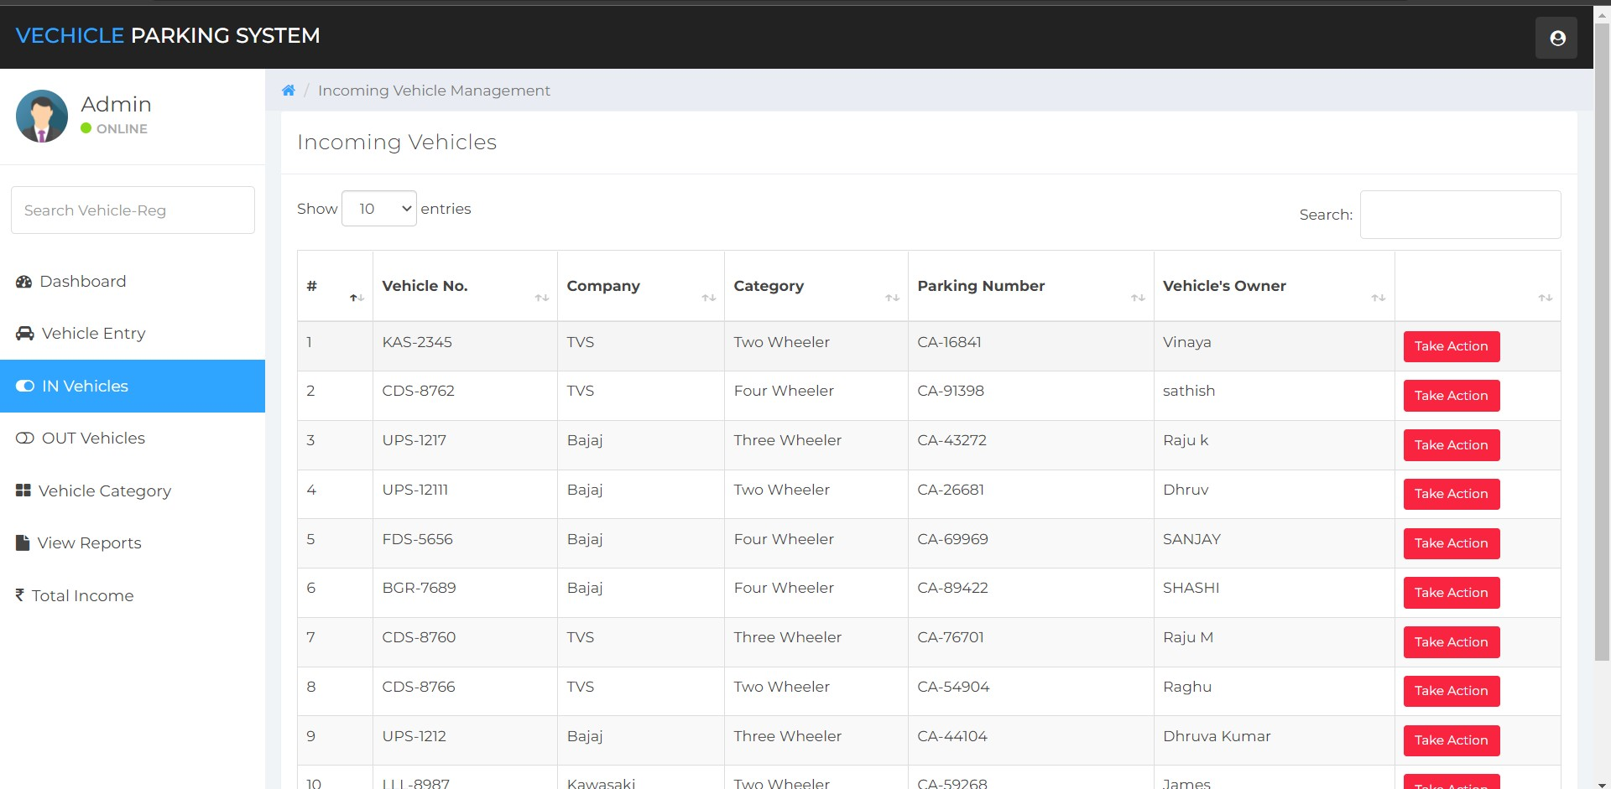

Fig: 5.1.5 List of in vehicles

With the help of in-vehicle feature, details about all the vehicles in the parking area along with the owner name is listed. Here we can limit the entries shown using the option available.

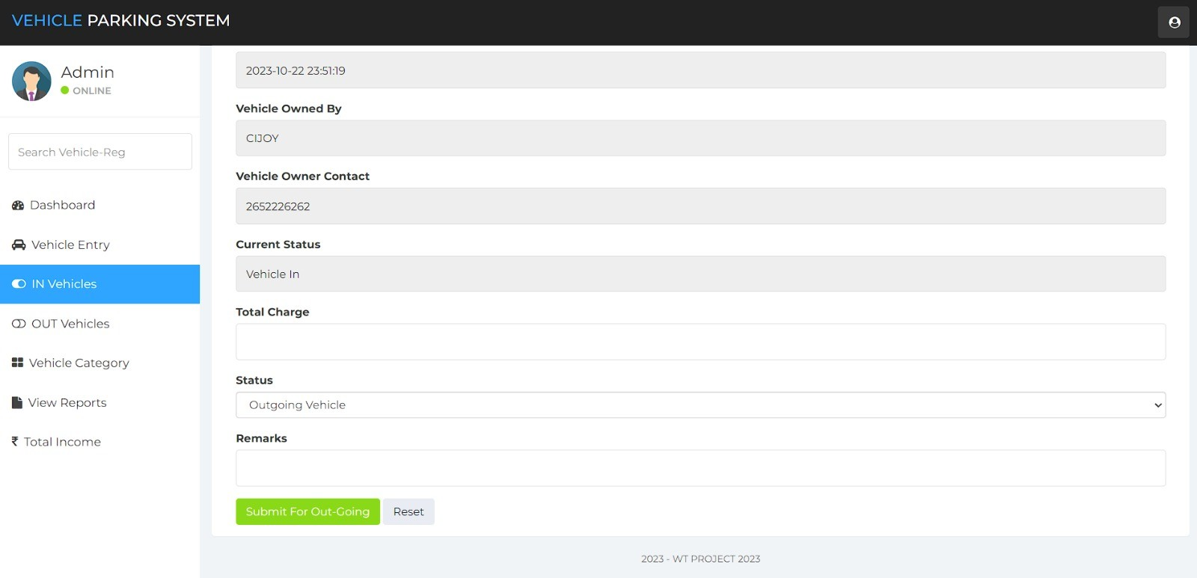

Fig: 5.1.6 Take action for in vehicles

For the in-vehicles, admin can take action that is, if the vehicle is moving out then parking charge need to be entered by admin and provide a remark.

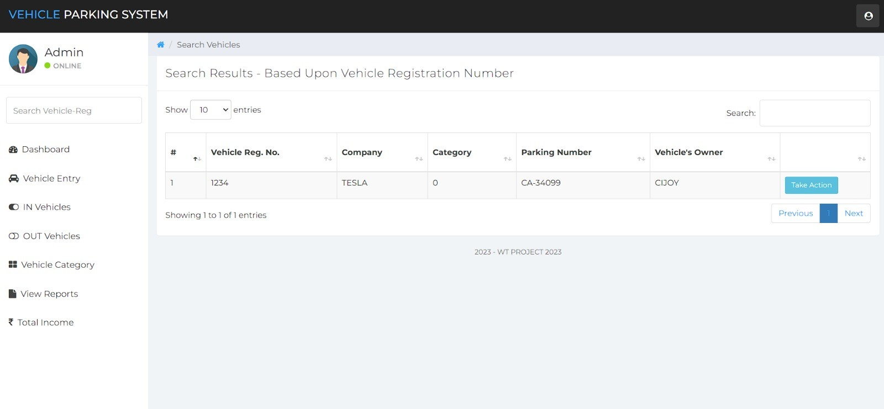

Fig: 5.1.7 Searching for a vehicle details

There is search option available in in-vehicles feature. Admin can search for a particular vehicle using parking number or vehicle registration number.

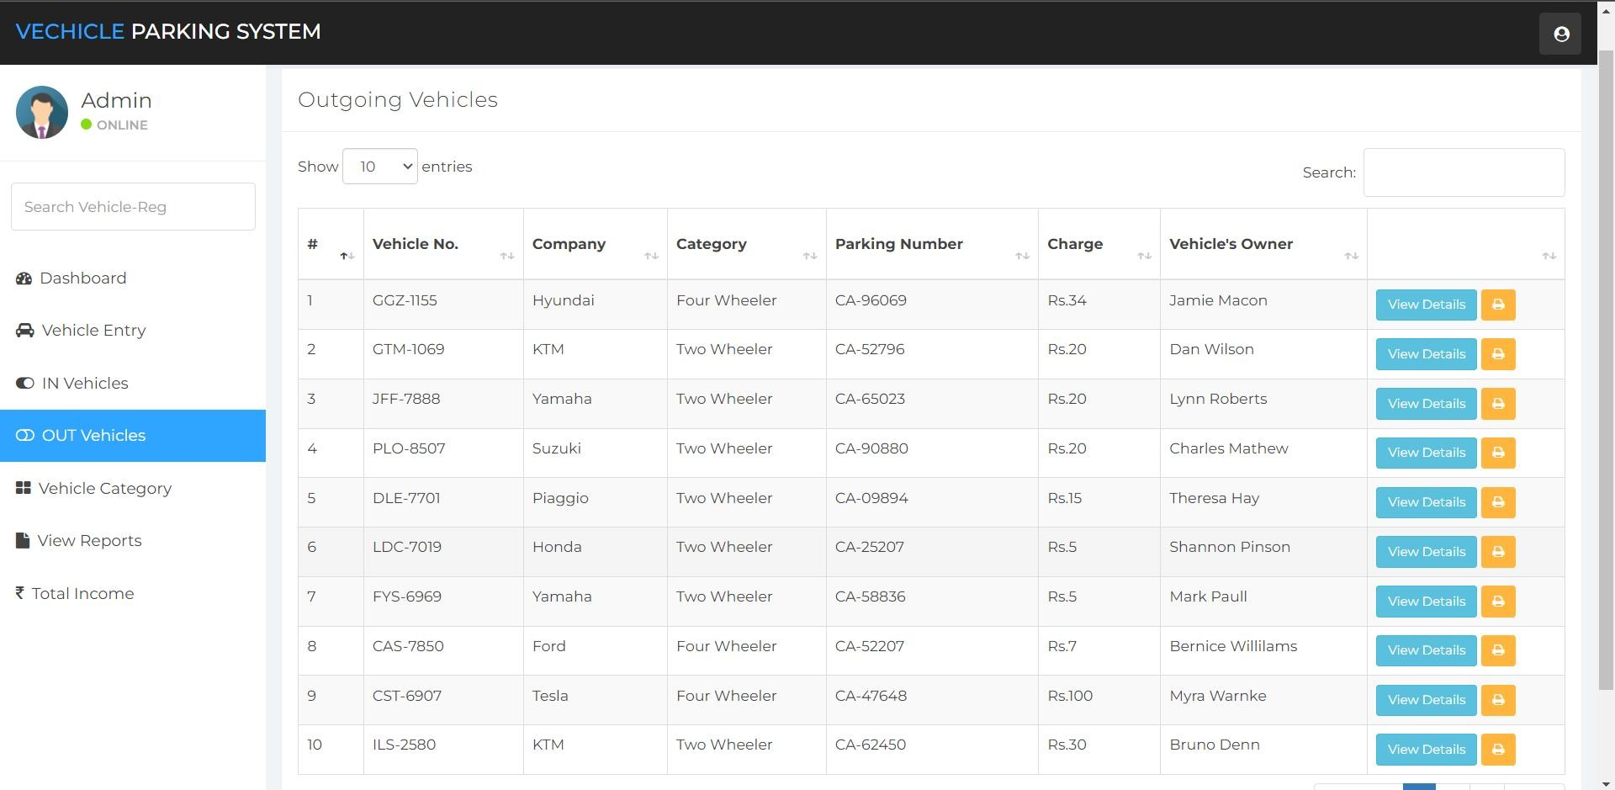

Fig: 5.1.8 List of out vehicles

With the help of out-vehicle feature, details about all the vehicles moved out of parking area along with the owner name is listed. Here we can limit the entries shown using the option available. And also search for particular vehicle using parking number or vehicle registration number.

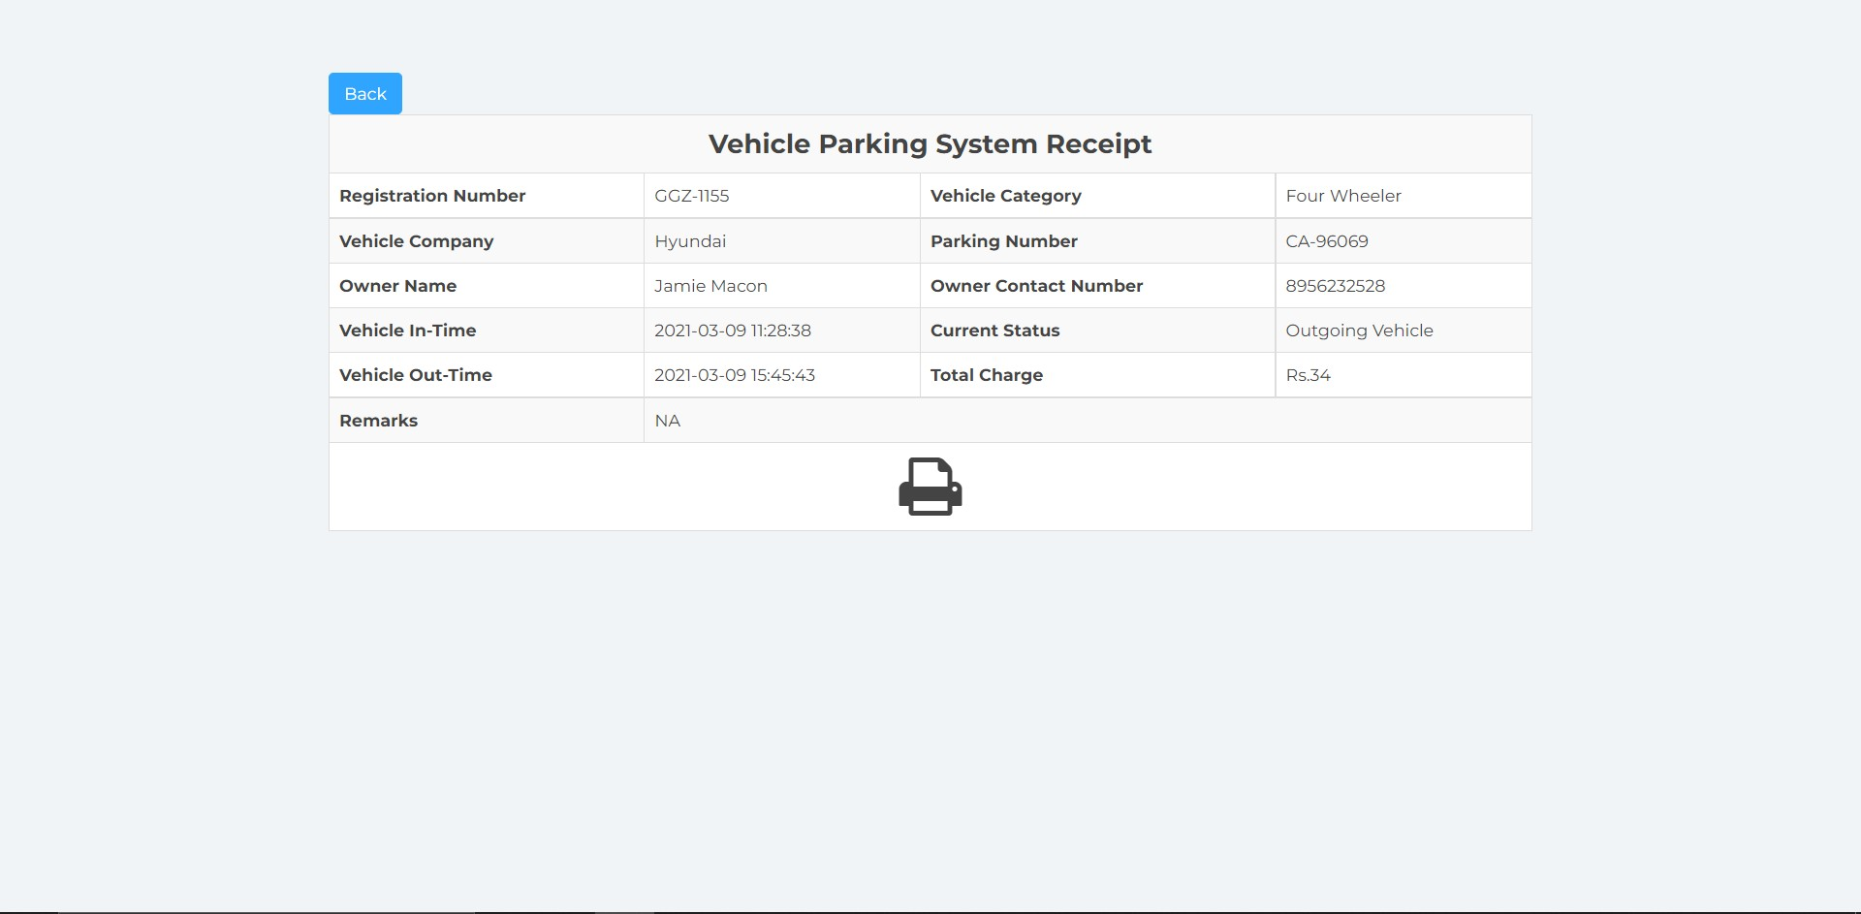

Fig: 5.1.9 Receipt

Receipt can be generated with the view-details option available in out-vehicle bar. Details about vehicles, owner along with vehicle in-time and out-time is available.

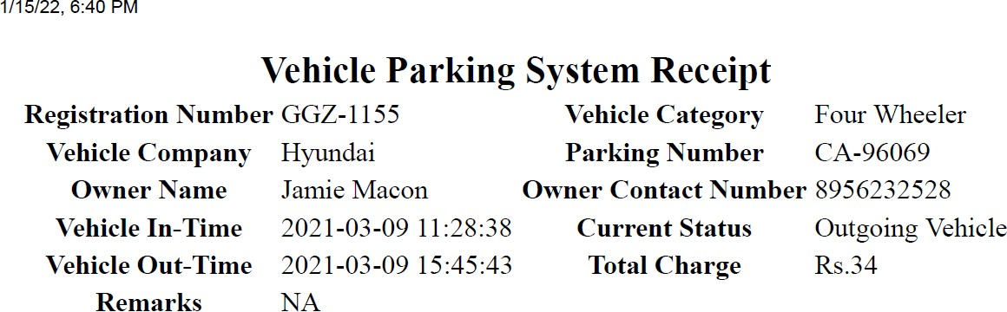

Fig: 5.1.10 PDF Copy of Receipt

Details about vehicles, owner along with vehicle in-time and out-time available can be printed. And the pdf format of the receipt looks like the above.

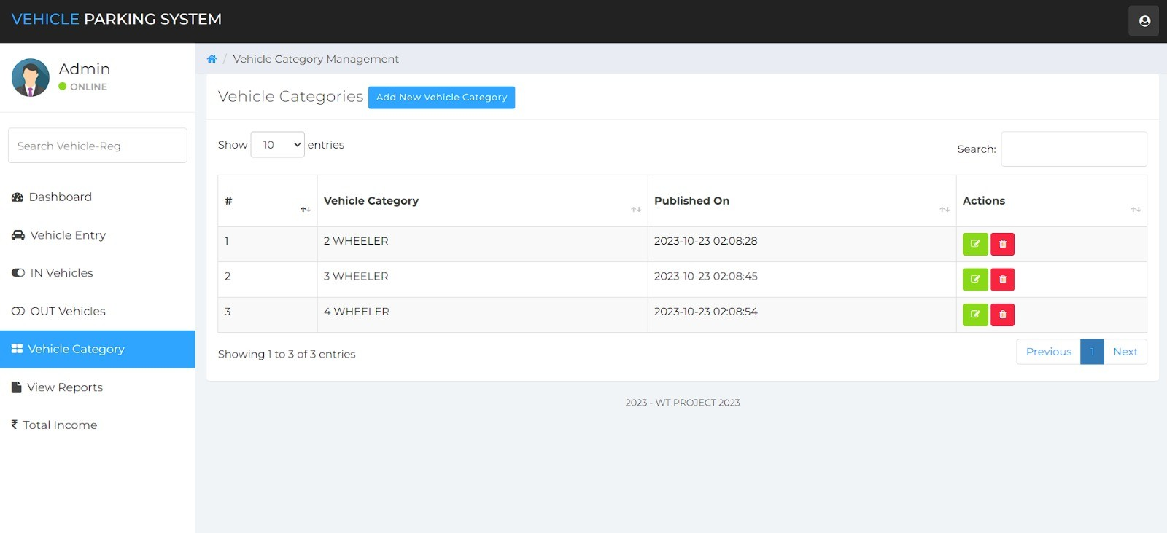

Fig: 5.1.11 List of vehicle categories

New vehicle category can be added or existing can be deleted with the vehicle category feature. And even we can search for the vehicle category with the search option.

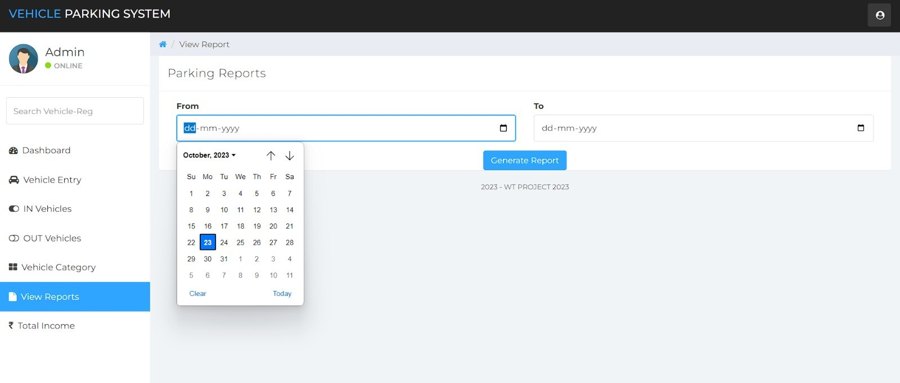

Fig: 5.1.12 View reports with in particular period

Admin can view the reports within particular period by specifying the from date and to date in the mentioned format dd-mm-yyyy only.

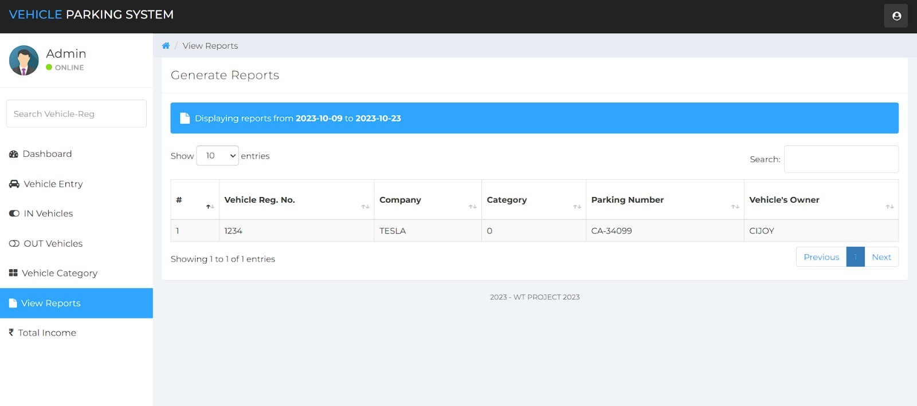

Fig: 5.1.13 Vehicle Report

Admin can view the reports within particular period by specifying the dates. After pressing generate button, list of vehicle entries can be seen.

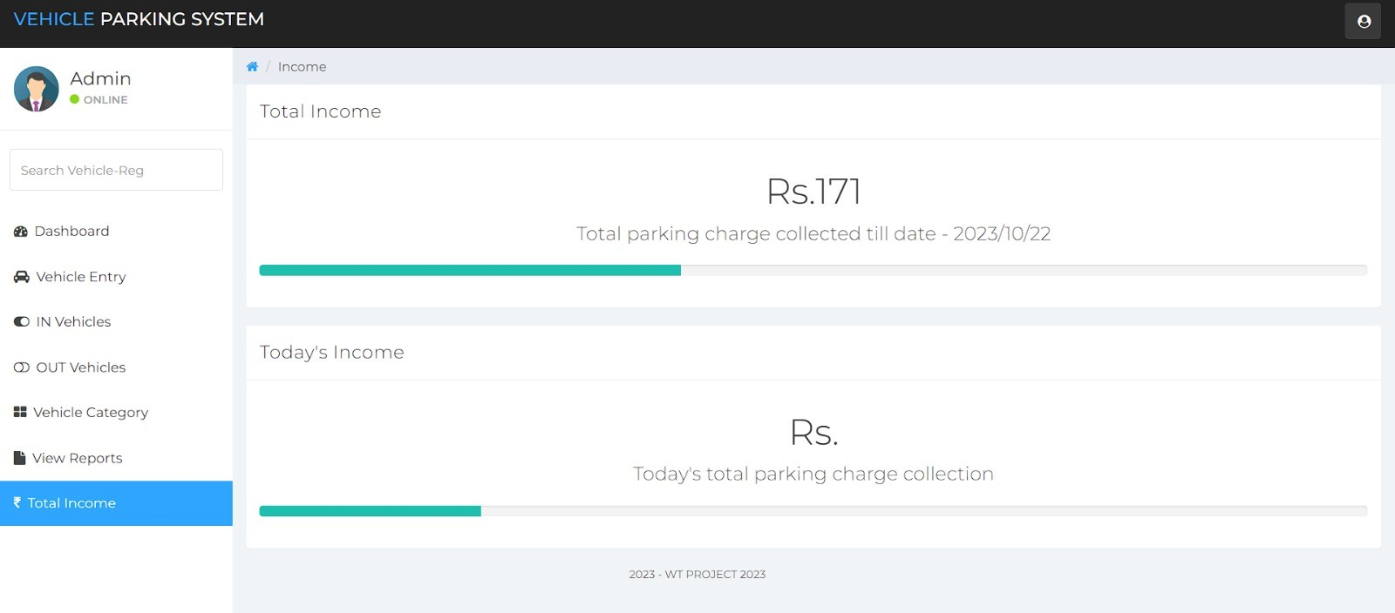

Fig: 5.1.14 Total income

With the total income feature, total income earned till date as well as that days income can be seen by admin.

https://github.com/Chetan-Lande/WebTechnologyProjectTE.git

**GITHUB LINK :**

**Thank You**